**Toeic test 4**

1. **Look at the picture and listen to the sentences. Choose the sentence that best describes the picture:**

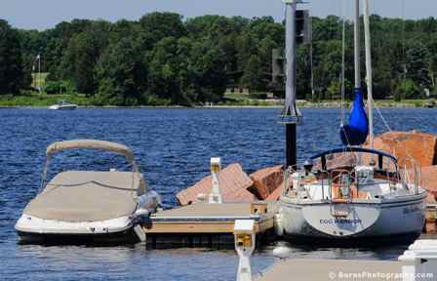

* A
* B
* C
* D

1. **Listen to the question and the three responses. Choose the response that best answers the question:**

* A
* B
* C

1. **Listen to the dialogue. Then read each question and choose the best answer:**

* What will Bill most likely do next?

1. Order some office supplies.
2. Negotiate a new contract.
3. Delay a meeting.
4. Make a phone call.
5. **Listen to the talk. Then read each question and choose the best answer:**

* Where is the speaker calling from?

1. The office
2. A restaurant.
3. Her home.
4. A hospital.
5. **Choose the word that best completes the sentence:**

* The Victoria Hotel, -------- we stayed during our summer vacation, will be torn down for extensive renovations.Easy.

1. When
2. Where
3. In that
4. In it
5. **Choose the word or phrase that best completes the blanks:**

Luis Hawkins

105 Mt. Wellington Lane Auckland, New Zealand

March 2, 2007

Mr. Berman

Ave. Simon Bolivar 359 Monterrey 6400

Mexico

Dear Mr. Berman,

The other day, I attended a seminar where you gave a presentation entitled “Ideal Renovation”. I found your talk very (65)........ Our company has been selected to renovate the Hempha Library, which is one of the biggest libraries scheduled to be (66)........ renovations soon, to enhance library services for the community. It would be of much help to have your ideas and suggestions as a consultant on the project from the outset, (67)........ we are considering how to best meet the needs of the prominent library. We are looking forward to doing business with you.

Sincerely,

Luis HawkinsMuch

1. Interested
2. Interest
3. Interest
4. Interestingly
5. **Read the passage and choose the correct answer:**

* Received: Monday, June 4th, at 8:32 p.m.

From: peter.lasco@allwalls.com

Re: Appointment Cancellation

Mr. Walker,

I apologize for having to cancel our appointment last Friday at the last minute. There was some urgent business at another job site, and I had to attend to it personally. I hope that we can reschedule for sometime next week.

Also, in your last e-mail you asked for some different options with regard to materials and our turn-around time. The sample books I couriered to you last week are the standard wallpapers that we use – 1.75 meter-wide, printed. But we have also started using a new process with large, floor-to-ceiling rolls that produces a papered wall without seams. The papers are the highest grade, and most have silk highlights. As your project is a luxury apartment complex, these products may better suit your needs. This is a specialty process, requiring special equipment, and so there would be additional charges on top of our usual labor costs. Since you would be doing so many units in your building, perhaps we could offer you a discounted rate on the labor. I will discuss this possibility with our sales manager and let you know when we meet.

With regard to our turn-around time, using standard-process papers we would be able to complete the 15 units in one week. The seamless wallpaper application process makes use of a large roller mechanism; so, potentially, we could complete the work in 3 days. Again, I am sorry to cancel our appointment. Please let me know at your earliest convenience when you would like to reschedule. Thank you.

Sincerely,

Peter Lasco

Sales Rep,

All Walls, Inc.

* How long does Mr. Lasco estimate the job will take?

1. More than 15 days.
2. Until some time next week.
3. Three days with the new process.
4. Three days with the new process.